Module 7) JQuery Basic, Effects & Advanced

Q-1) What is jQuery?

A-1) Query is a fast and small JavaScript library.

**jQuery**is an open source JavaScript library that simplifies the interactions between an HTML/CSS document, or more precisely the Document Object Model (DOM), and JavaScript.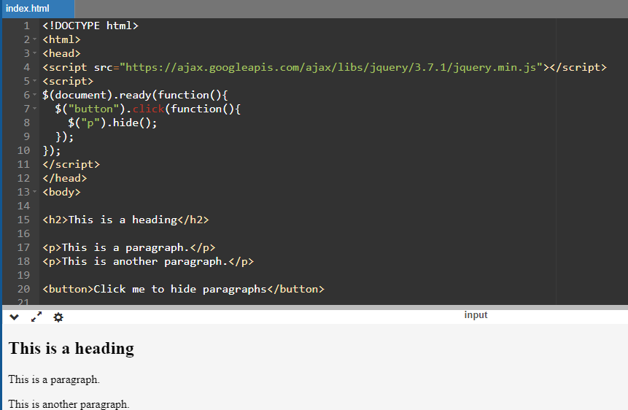

Q-2) How to Apply CSS Using JQuery, how to Add Class and Remove Class in Jquery, JQuery Animation?

A-2) multiple types of css using jQuery.

* addClass ()
* removeClass ()
* toggleClass ()
* css()

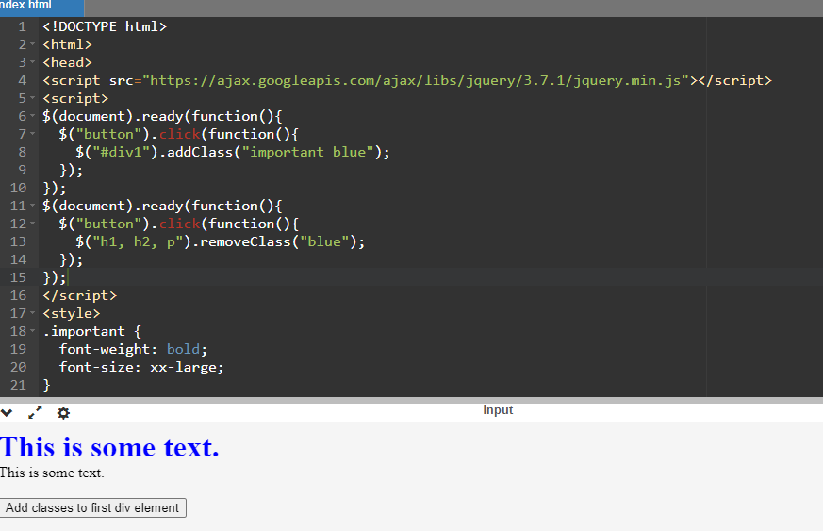

jquery animation:

The jQuery animate() method is used to create custom animations.

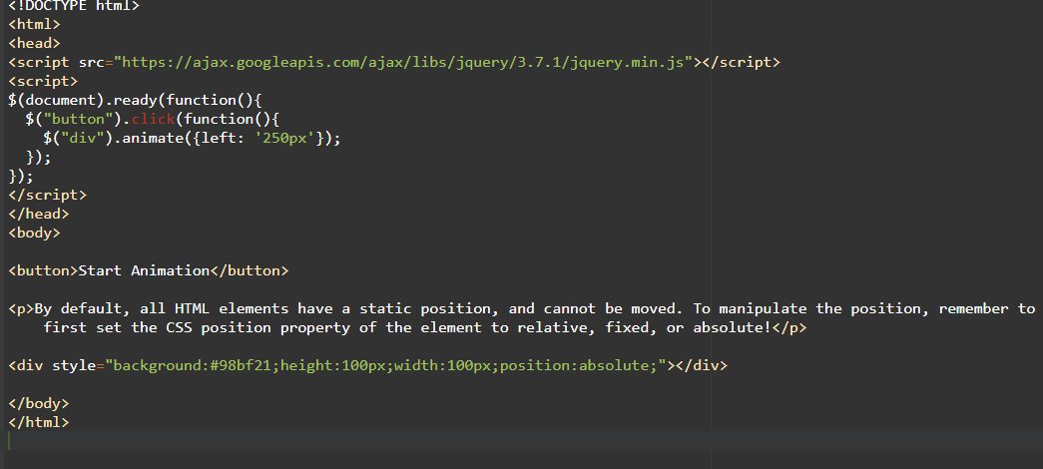

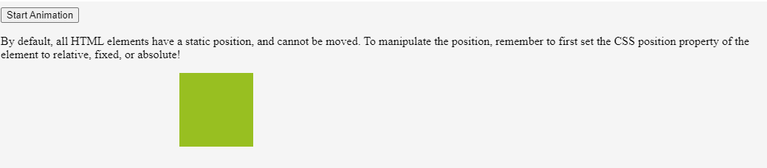

Q-3)How to create slider with animation?

A-3) The jQuery animate() method is used to create slider

with animations.

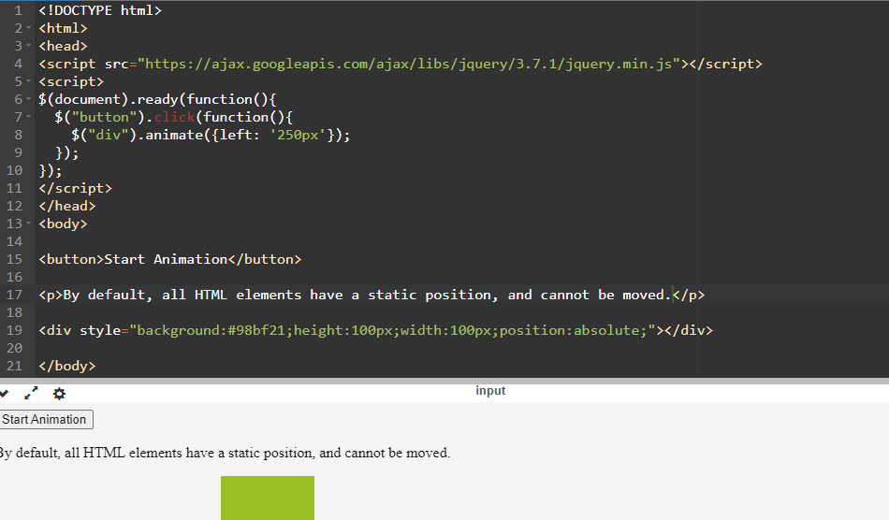

Q-4)Event bubbling tickling example.

A-4) Event bubbling is the propagation of events from the bottom to the top of the DOM tree, from child elements to parent elements.